A NOTTINGHAM POETRY FESTIVAL EVENT:

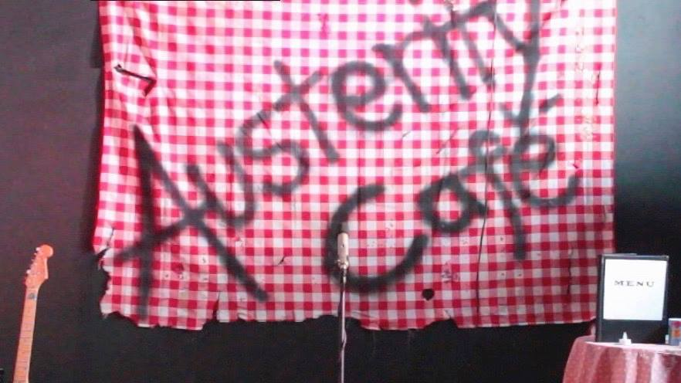

A POP UP POLITICAL MUSICAL
WITH POETRY AND MUSIC

Join Yannis, and customers, as he serves up his unique, half-cooked philosophies. Chopped up opinions are thrown into a sizzling pan of stewed beliefs. Enjoy!

@ JAM CAFÉ, 12 Heathcoat St, Nottingham NG1 3AA

SATURDAY 28TH APRIL, 17:30 -19:30

With Andy Szpuk and Paul Quadros FREE

